Writing Linear Equations WS #4 Name:
Period:
Write the equation of the line in slope-intercept form that passes through the given points
- $\left(2 , 1\right)and ((5 , 2)$ | - $\left(3 , -1\right)and (12 , 2)$
- $\left(2 , 8\right)and (-3 , -12)$ | - $\left(1 , 5\right)and (-3 , 5)$
- Use the graph to determine the equation of the line  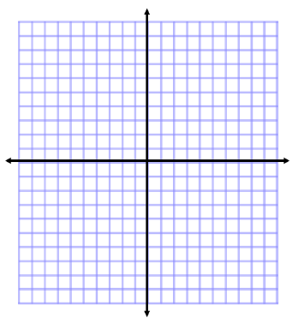 | - Identify the slope and y-intercept  $$3x-2y=10$$

