Writing Linear Equations WS #5 Name:

Identify the slope and y-intercepts
- $y=\frac{2}{3}x-5$ | - $2x+y=1$ |  | - $-6x-2y=4$
Use the graphs to identify the slope and y-intercept
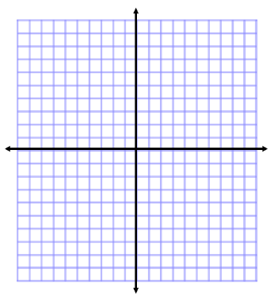
Write the equation of the line with the given slope and y-intercepts
- $slope=2$ ; $y-int=5$ | - $slope=1$; $y-int=0$ |  | - $slope=zero ;$  $$y-int=-3$$
Write the equation of the line with the given information
- Slope : -2  Point: (-3 , 6) |  | - Pass through the points (-3 , -1) and (6 , 5)
- Pass through the points (-3 , 6) and (9 , 2) |  | - Pass through the points (5 , 10) and (-4 , -8)

